39.52: a) 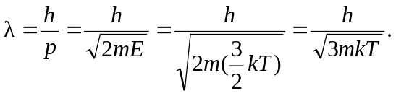
b) We would roughly expect the length scale of the problem to go like 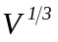 (e.g., for a cube 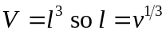 and for a sphere 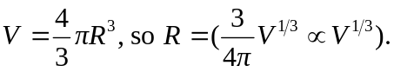 Let n be the number of molecules along one length (again, think of a cube) so that 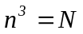, the total number of particles in the volume. So 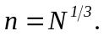Thus, the typical spacing between particles is 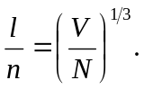 The exact relationship will change depending on the geometry, but the scaling is correct up to a multiplicative constant.
c) 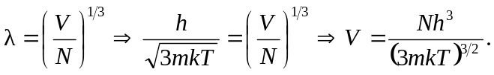
d)
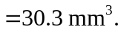
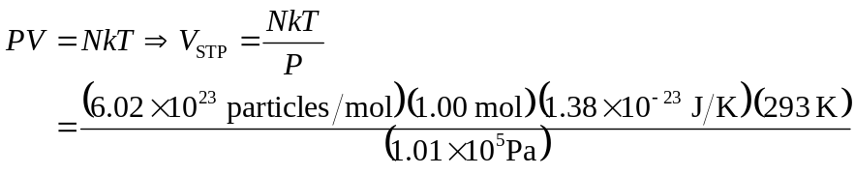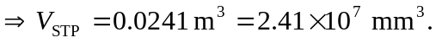
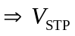 is far larger than 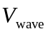 so the wave nature is not important. 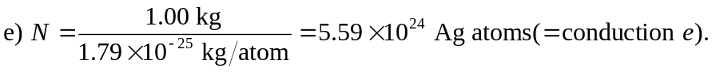
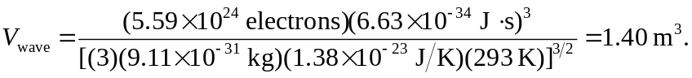
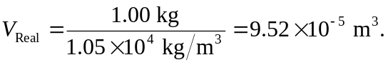
The real volume is much smaller than the wave limit volume. So, the wave nature of the electrons must be accounted for.

